First EMG team Writing Retreat- Denmark
The Copenhagen Business School hosted the EMG-K team for the projects first writing retreat. The team gathered in Elsinore- Denmark in August 2023. The team was able to work on the first drafts for research publications on the following topics: IMO's capacity to mitigate climate change from international shipping; Kenya's IMO and UNFCCC engagement; Compliance and enforcement challenges in maritime environmental governance

Photo: EMG-Team at Elsinore writing retreat. August 2023.
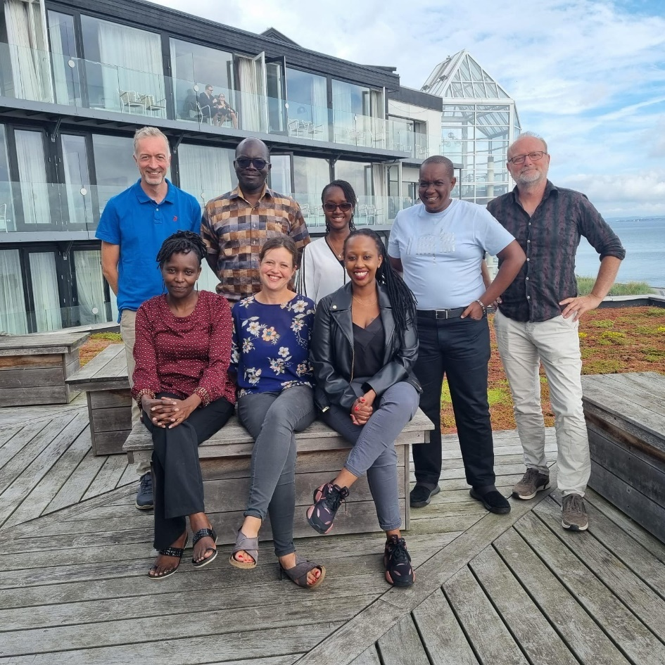
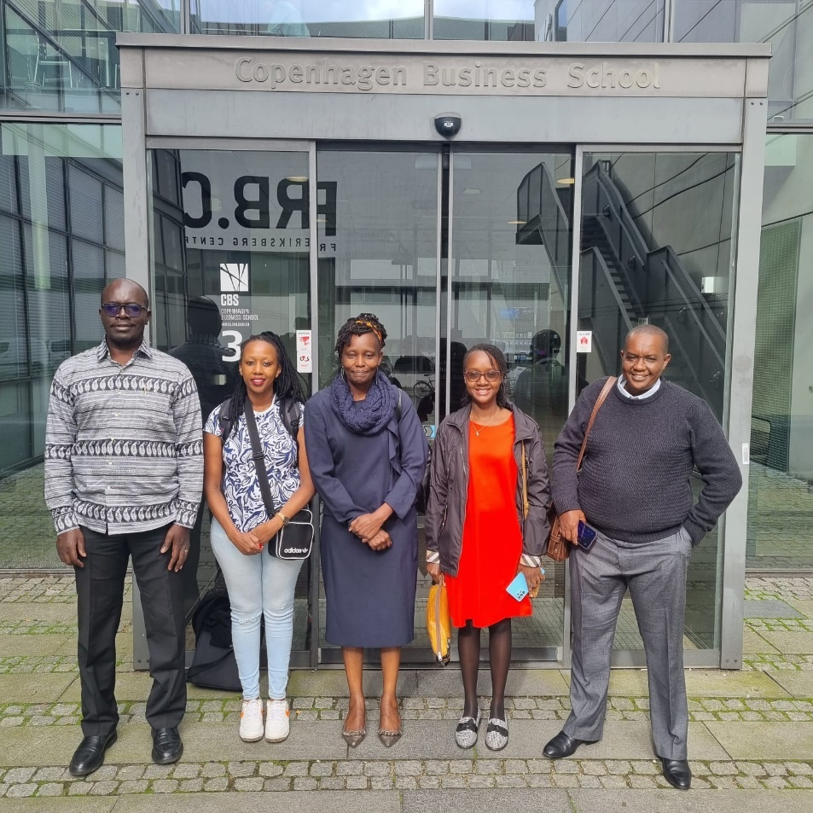
The CASELAP team visit the Copenhagen Business School during the writing retreat.
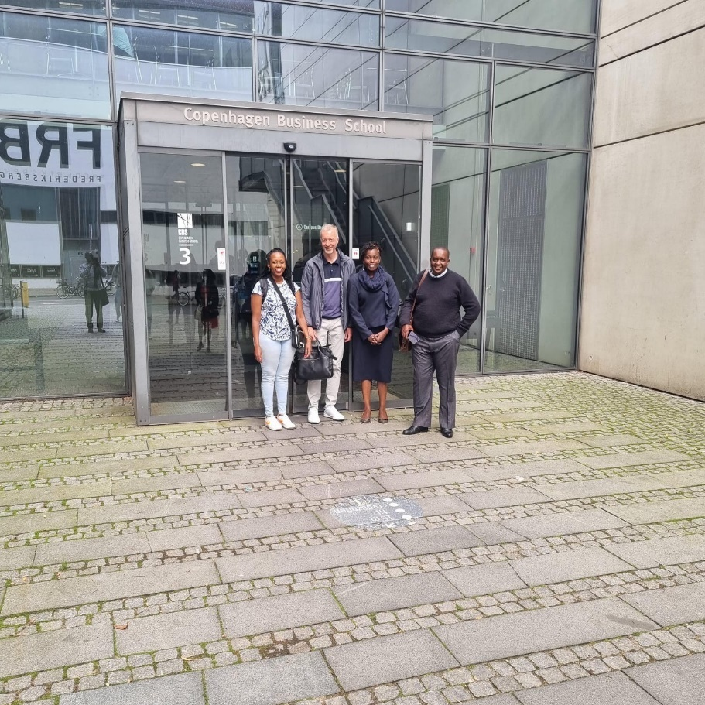

Our Masters Student graduated!
Fred Kungu graduated with a Master’s degree in Environmental Policy in December 2024 from The Faculty of Law. University of Nairobi. Fred was supported by the EMG- Project for his research. His thesis topic was, “Evaluating Kenya's Capacity and Readiness for Handling Hazardous and Noxious Substance Spills In Maritime Environments”

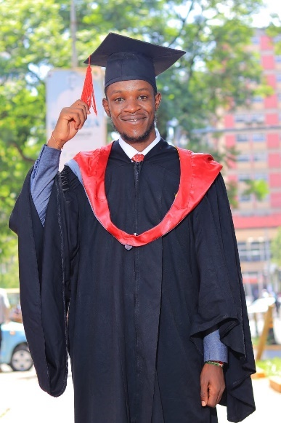

Courtesy Call to the Principal Secretary Shipping and Maritime Affairs - Nairobi
On 4th of December 2024, Prof. Collins Odote and Prof. Rene Taudal Poulsen of Copenhagen Business school paid a courtesy visit to the Permanent secretary Geofrey Kaituko. The three had a great discussion on elevating Kenya’s Maritime sector to the global level. The Permanent Secretary assured the team on the governments commitment to supporting the EMG- Kenya initiative generally in the context of the proposed Maritime sector collaboration between Kenya and Denmark.
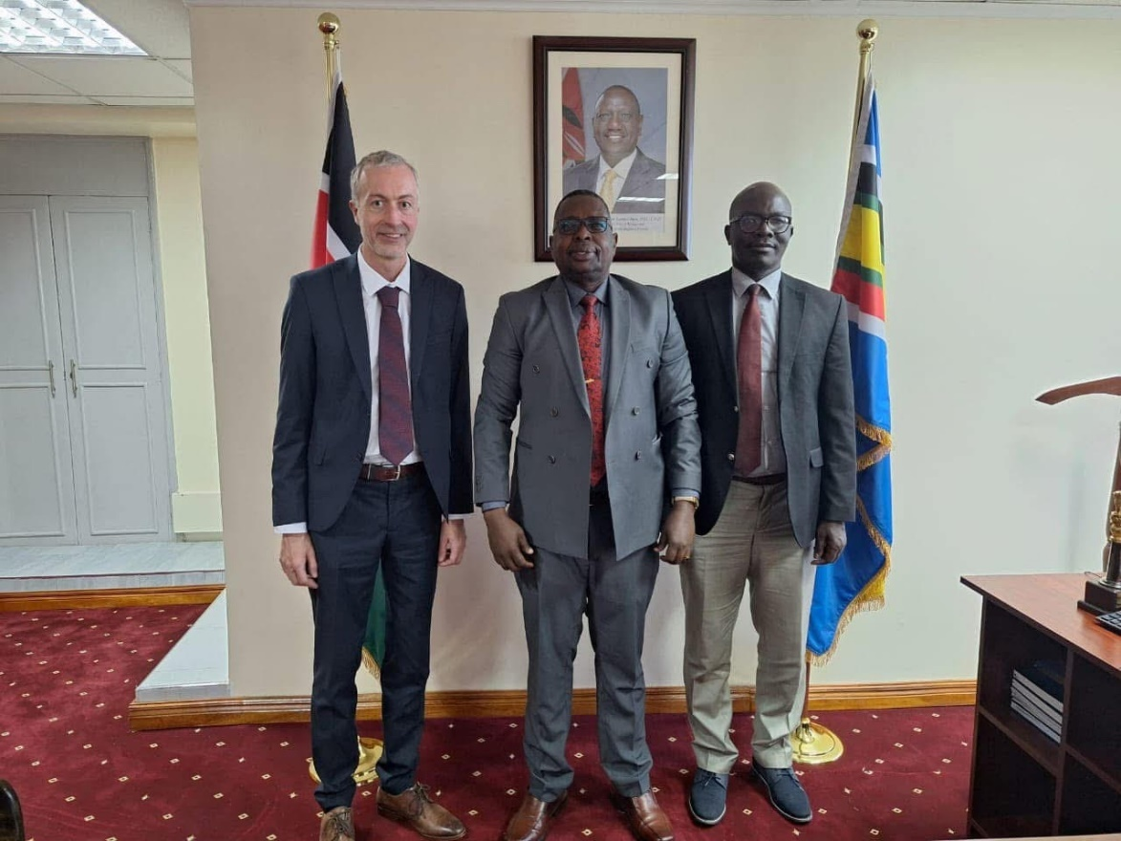
Photo. Courtesy of EMG-K- From left Prof, Rene, Ps Kaituko and Prof. Odote. 4th December 2024

Participation at the IMO Negotiations in London.
The EMG-K team were part of the Kenya delegation at the 17th session of ISWG- GHG and the 82nd session of the MEPC in London from the 23rd to 27th September 2024 and to 30th to 4th October 2024.

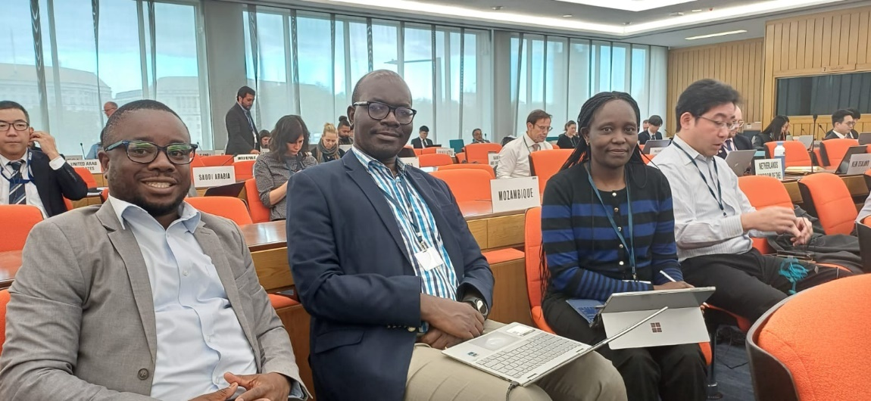
Photo. EMG-K team together with staff from Kenya Maritime Authority attending the IMO negotiations in London.

Participation at the 66th Annual Convention: Reconnecting International Studies in Chicago. (March 2nd - 5th, 2025)
Prof. Collins Odote together with Colleagues from Copenhagen Business School attended the 66th Annual Convention: Reconnecting International Studies. The Convention was held from March 2nd - 5th, 2025, organized by the International Studies Association. The meeting was held at the Hilton Chicago, Palmer House Hilton, and The Blackstone hotels in Chicago, Illinois, USA.

He was invited in the capacity of an Author on Paper: "Drawing Boundaries for Sectoral Climate Governance: Top-down Climate Change Mitigation for International Shipping Outside the UNFCCC" for Panel "Political Economy of Climate Governance". Tuesday, March 4, 2025, 10:30 AM. The 2025 Convention represented a unique opportunity for sharing information within the community of international scholars.

EMG team writing retreat- Mombasa from (May 19- 23rd 2025)
The EMG-K team – members from CASELAP at University of Nairobi and Copenhagen Business School held a one week writing retreat in Mombasa to advance research on shipping and climate governance. This interdisciplinary group developed journal articles addressing sectoral climate governance, compliance mechanisms and the domestication of IMO measures, emphasizing Africa's growing influence on global maritime policy. Discussions tackled critical challenges: uneven African participation in IMO negotiations, technical capacity gaps and tensions between climate goals and development needs.
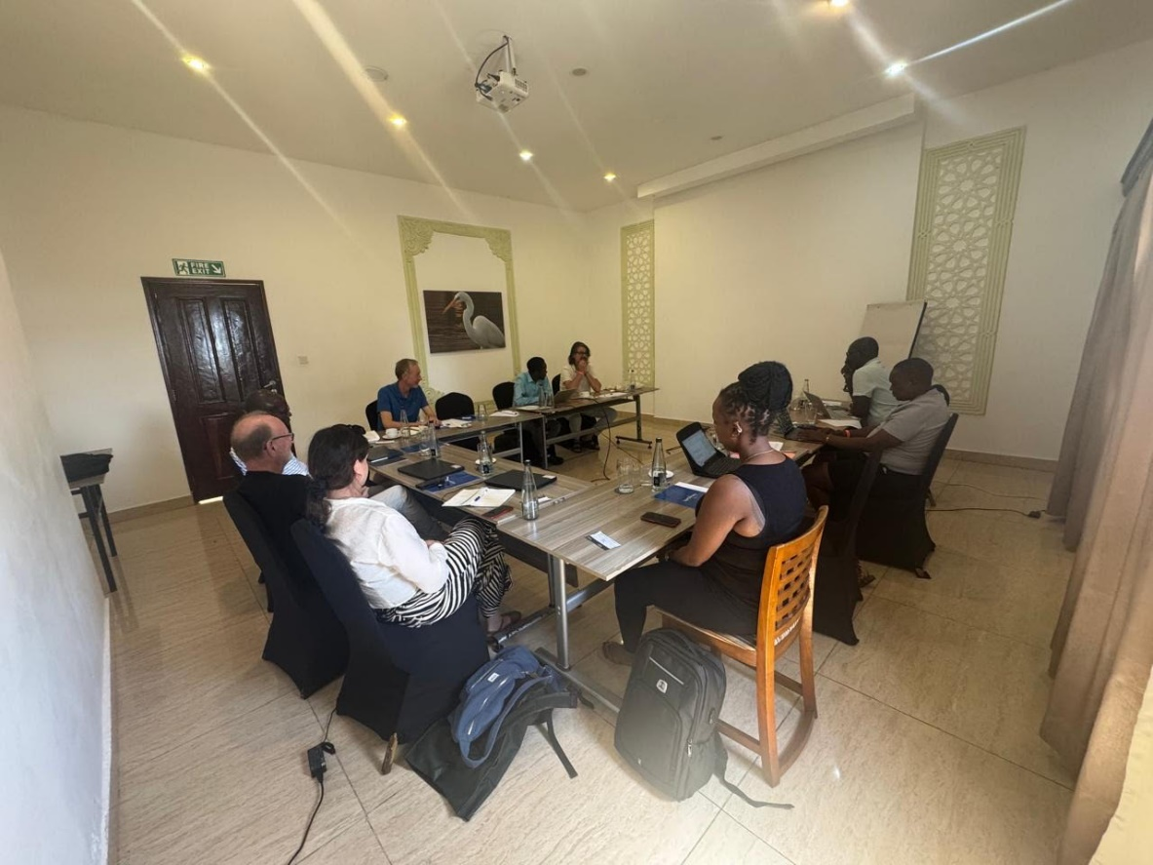
Photo : EMG writing retreat May 2025

Mombasa stakeholder workshop 22nd May 2025
The EMG Team joined their counterpart ILEG at a workshop at Kenya Marine Fisheries Institute in Mombasa on 22nd May 2025 where maritime stakeholders examined Kenya's shipping decarbonization priorities. The ongoing work underscored the urgent need for equitable transitions, capacity building and meaningful African engagement as the IMO shapes its net-zero framework, ensuring developing nations' perspectives guide this critical transition. This was a great opportunity for the team to interact with key stakeholders of maritime governance in Kenya and also an opportunity to flag some of the project research findings from three years of IMO research.

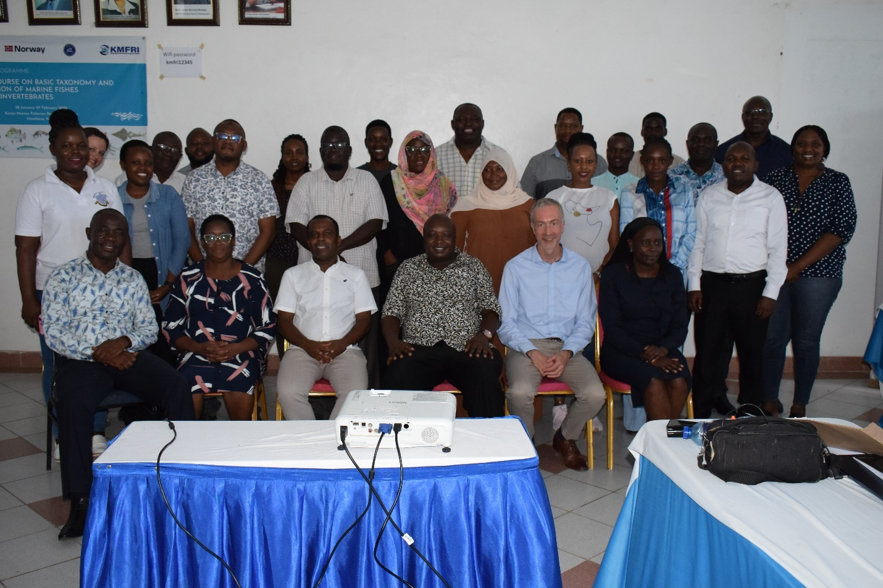

Photo Courtesy of EMG- K- Participants at the Mombasa Workshop.

Publications

Prof. Odote from CASELAP published a newspaper article in Kenya's "Business Daily" on shipping GHG policy on March 13, 2023: https://www.businessdailyafrica.com/bd/opinion-analysis/columnists/keep-t-kenya-s-stand-on-shipping-industry-pollution-open--4155780
Here is the link to EMGK article published on Maritimafrica website:
https://maritimafrica.com/en/navigating-net-zero-how-amendments-to-marpol-annex-vi-will-shape-africas-maritime-future/
Links to the publication on social media:
Facebook: https://www.facebook.com/share/p/1B4q7pEKjA/
Twitter/X: https://x.com/maritimafrica/status/1948068679964352750
LinkedIn: https://www.linkedin.com/feed/update/urn:li:activity:7353833894409838593

